SIMATS ENGINEERING (SAVEETHA SCHOOL OF ENGINEERING)
Department of Computer Science and Engineering
CO2_AT1 — CHART CONSTRUCTION TEST

Course Code: | DSA06 | Course Title: | Data Handling and Visualization
CO Assessed: | CO2 – Construction (BL3) | Assessment: | Assessment Tool 1 – Chart Construction
Weightage: | 20% of CIA | Total Marks: | 25 (5 Questions × 5 Marks)
CO2 Statement: | Apply appropriate chart construction techniques — correct chart type, axes, scales, and calculations — to accurately represent given data.(BL3)
Student Name: |  | Reg. No.:
Section / Batch: |  | Date:

Code of Conduct
I 192424393 (Name / Reg No) certify that this submission is my original work and that I have adhered to the guidelines specified for this assessment. I understand that any violation of academic integrity rules will result in disciplinary action.

Signature of the Student: A M RAKESH

Instructions
- This test contains 5 questions, each carrying 5 marks. Total: 25 Marks.
- No negative marking. Unanswered questions carry zero marks.
- No calculators or electronic devices permitted.
- Duration: 75 minutes.
- Graph paper or a ruler is recommended for accurate, to-scale drawing.
- Show all calculations (e.g., percentages, angles, bin ranges, five-number summaries) as part of your answer.
- Every chart must include a title, correctly labeled axes, and a legend where applicable.

Annexure A – CHART CONSTRUCTION

Rubrics for Calculation ASSESSMENT RUBRIC
AT1 — Chart Construction Test
CO2 · BT3: Apply ·
This rubric is used to assess student responses to the CO2-AT1 Chart Construction Test, in which students are given a small dataset and must construct an accurate, correctly labeled chart of a specified type.

Criteria | Weightage | Level 4 – Exemplary | Level 3 – Proficient | Level 2 – Developing | Level 1 – Beginning
Understanding of Concepts | 25% | Demonstrates thorough, accurate understanding of the correct chart type, and the axes, scale, and elements required to construct it for the given data. | Good understanding of the required chart type and construction elements, with only minor gaps. | Basic understanding of chart construction, but with some misconceptions about the correct chart type, axes, or scale. | Poor understanding of core construction concepts; selects a chart type or elements fundamentally unsuited to the data.
Explanation | 25% | Shows detailed, clearly worked calculations (e.g., angles, bin ranges, five-number summary) and explains each construction step. | Shows clear calculations and construction steps, with adequate explanation for most parts. | Calculations or construction steps are shown but incomplete, or explanations are superficial. | Little or no working shown; calculations and construction steps are missing or unexplained.
Application | 20% | Effectively applies chart construction techniques to produce a complete, accurate chart correctly matched to the data. | Applies construction techniques to produce a correct chart, with only minor errors. | Limited application of construction techniques; the chart partially represents the data but has notable errors. | Fails to apply appropriate construction techniques; the chart does not correctly represent the data.
Organization | 15% | The chart is neatly and logically constructed, with a title, correctly labeled axes, a legend where applicable, and elements in a clear order. | The chart is well organized, with only minor issues in labeling, legend, or layout. | Basic construction; required elements (title, axes, legend) are present but poorly arranged or partly missing. | Poorly constructed; the chart is missing key elements such as a title, axis labels, or a legend.
Accuracy | 10% | The chart is completely accurate — all values, proportions, scales, and calculations correctly match the given data. | Mostly accurate, with only minor omissions or a small error in one value or calculation. | Partially correct; some plotted values, proportions, or calculations are missing or incorrect. | Largely inaccurate; major errors in plotted values, proportions, or calculations relative to the given data.

Scoring Guide
For each criterion, award a performance level (1–4) based on the descriptors above. Multiply the level achieved (as a percentage of 4, i.e., Level 4 = 100%, Level 3 = 75%, Level 2 = 50%, Level 1 = 25%) by the criterion's weightage, then sum across all five criteria to obtain the total score out of 100%.

Faculty In-charge | Course Coordinator | Head of Department
Signature: _______________ | Signature: _______________ | Signature: _______________
Date: ___________________ | Date: ___________________ | Date: ___________________

Data Visualization Selection Guide
Comprehensive Problem Statements, Solutions, & Embedded Charts
Problem 1 — Bar Chart — Basic Construction
Recommended Chart: | Bar Chart (Vertical Column Chart)
Rationale (Why): | Compares a numeric value (sales) across a small number of discrete, unordered-by-value categories (months). Bar height/position gives the most accurate visual comparison of magnitude between categories.
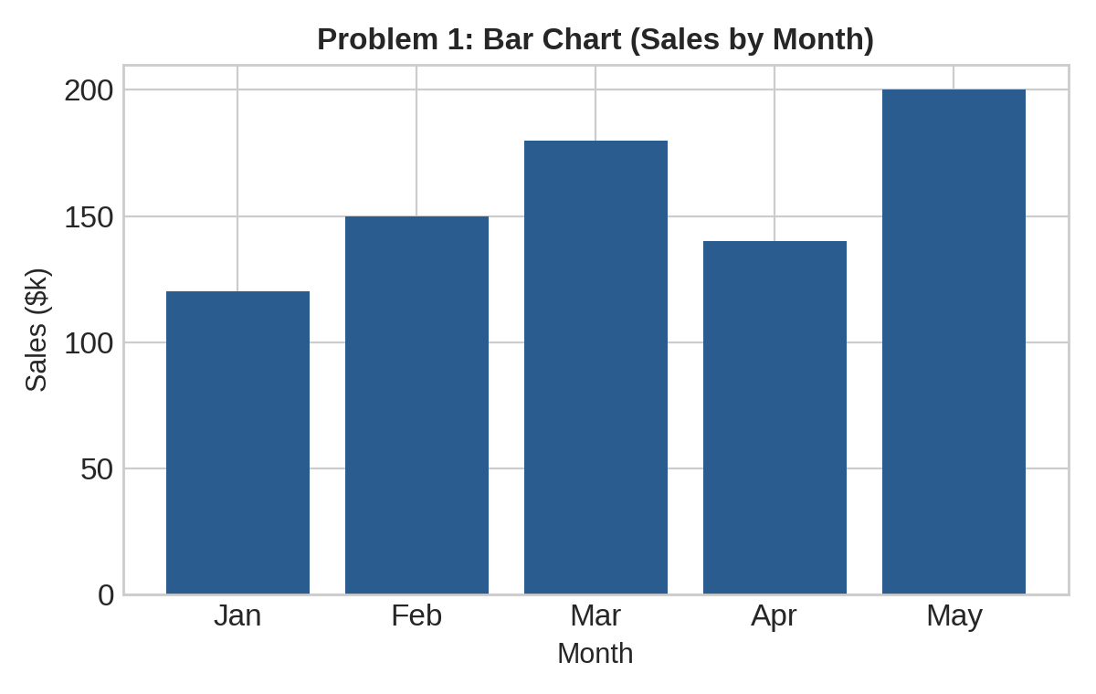

Problem 2 — Horizontal Bar Chart — Ranked
Recommended Chart: | Horizontal Bar Chart
Rationale (Why): | Five categories with longer text labels (traffic source names) read more easily left-to-right; horizontal orientation also makes ranking from highest to lowest easy to scan top-to-bottom.
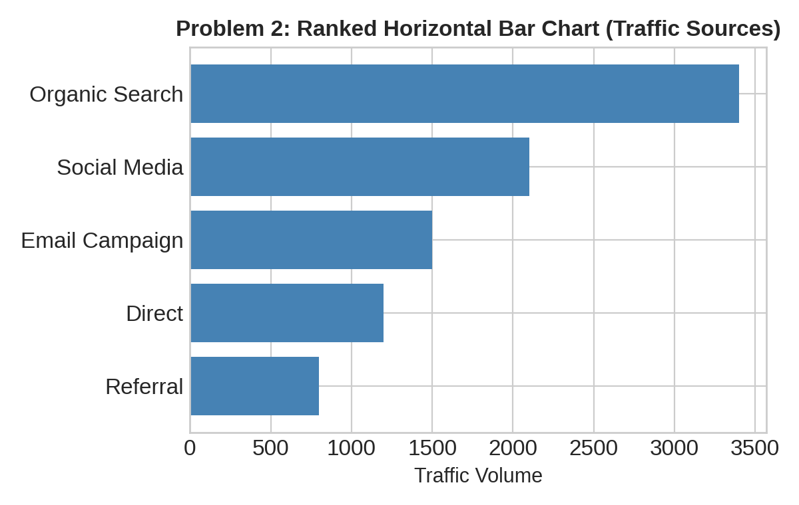

Problem 3 — Grouped (Clustered) Bar Chart
Recommended Chart: | Grouped (Clustered) Bar Chart
Rationale (Why): | Two series (Product A, Product B) need to be compared side-by-side within each of the same four categories (quarters), without one obscuring the other or requiring a stacked total.
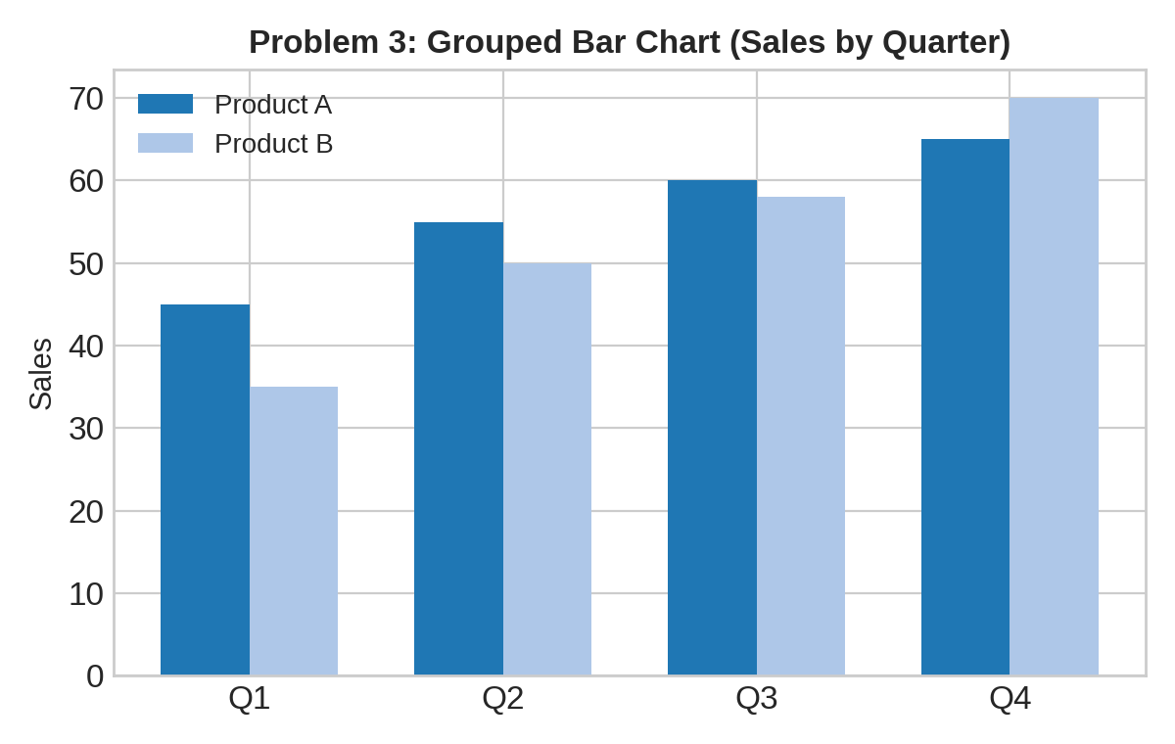

Problem 4 — Stacked Bar Chart
Recommended Chart: | Stacked Bar Chart
Rationale (Why): | Needs to show both the total headcount per year and how that total is composed of three departments — stacking preserves the grand total while still showing each department's contribution.
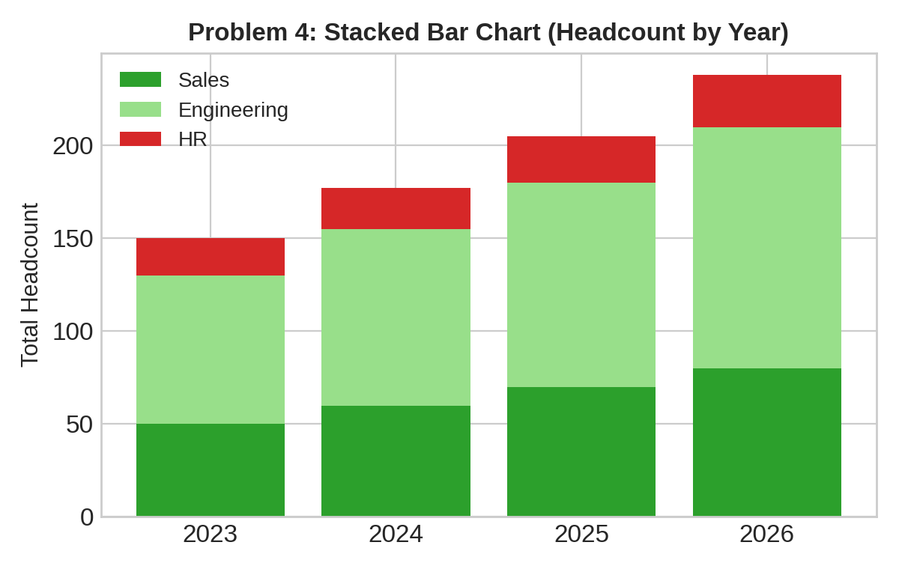

Problem 25 — Small Multiples Construction
Recommended Chart: | Small Multiples (four separate line charts)
Rationale (Why): | Four regions' trends need to be compared without the clutter of four overlapping lines on one chart; small multiples give each region its own panel with a shared scale, making individual trends easier to read while still allowing comparison.
